**RECYCLABLE ITEM DETECTION MODEL**

**ABSTRACT**

Waste management and recycling is the fundamental part of the sustainable development. Most of the people are not aware of the correct methods for disposing the waste products, especially in major cities it has become a crucial issue. The importance of recycling is well known for the betterment of our environment. In order to achieve the goal of sustainability one must know the difference between the recyclable and non-recyclable materials. We have taken an initiative to build a machine learning model which will identify the items and classify them into recyclable and non-recyclable products. In order to create a distinctive dataset, images were collected via various sources. The model has been trained using the Convolutional Neural Network to achieve the best accuracy. The model ensures the recycling of the quality materials and limits the harm that can be done downstream from poorly sorted, problematic or contaminated materials.

**INTRODUCTION**

Recycling of solid waste is a big challenge around the world. Human activities result in a lot of solid waste, without sorting solid-waste there is a negative impact on the environment. Recycling of solid waste problem in developing countries, such as India, has a number of aspects related to them, such as technological, official, financial, environmental and communal aspects.

When people are throwing away something seemingly useless, they are often in doubt: Is this recyclable or not? Recyclable items are valuable material rather than trash. By reusing recyclable items, a huge amount of energy cost to manufacture new materials and to deal with waste can be saved to help sustain a greener living environment for us all. Many kinds of glass, paper, metal, plastic, textiles, and electronics are recyclable materials, and should not be put into trash bins where non-recyclable materials should stay. But can people memorize all that recycling knowledge? No. However, with the help of a specific software, images of items that will be thrown away can be processed by computer vision and classified by supervised machine learning methods, thus intelligently tell users the recyclability of their items without pain.

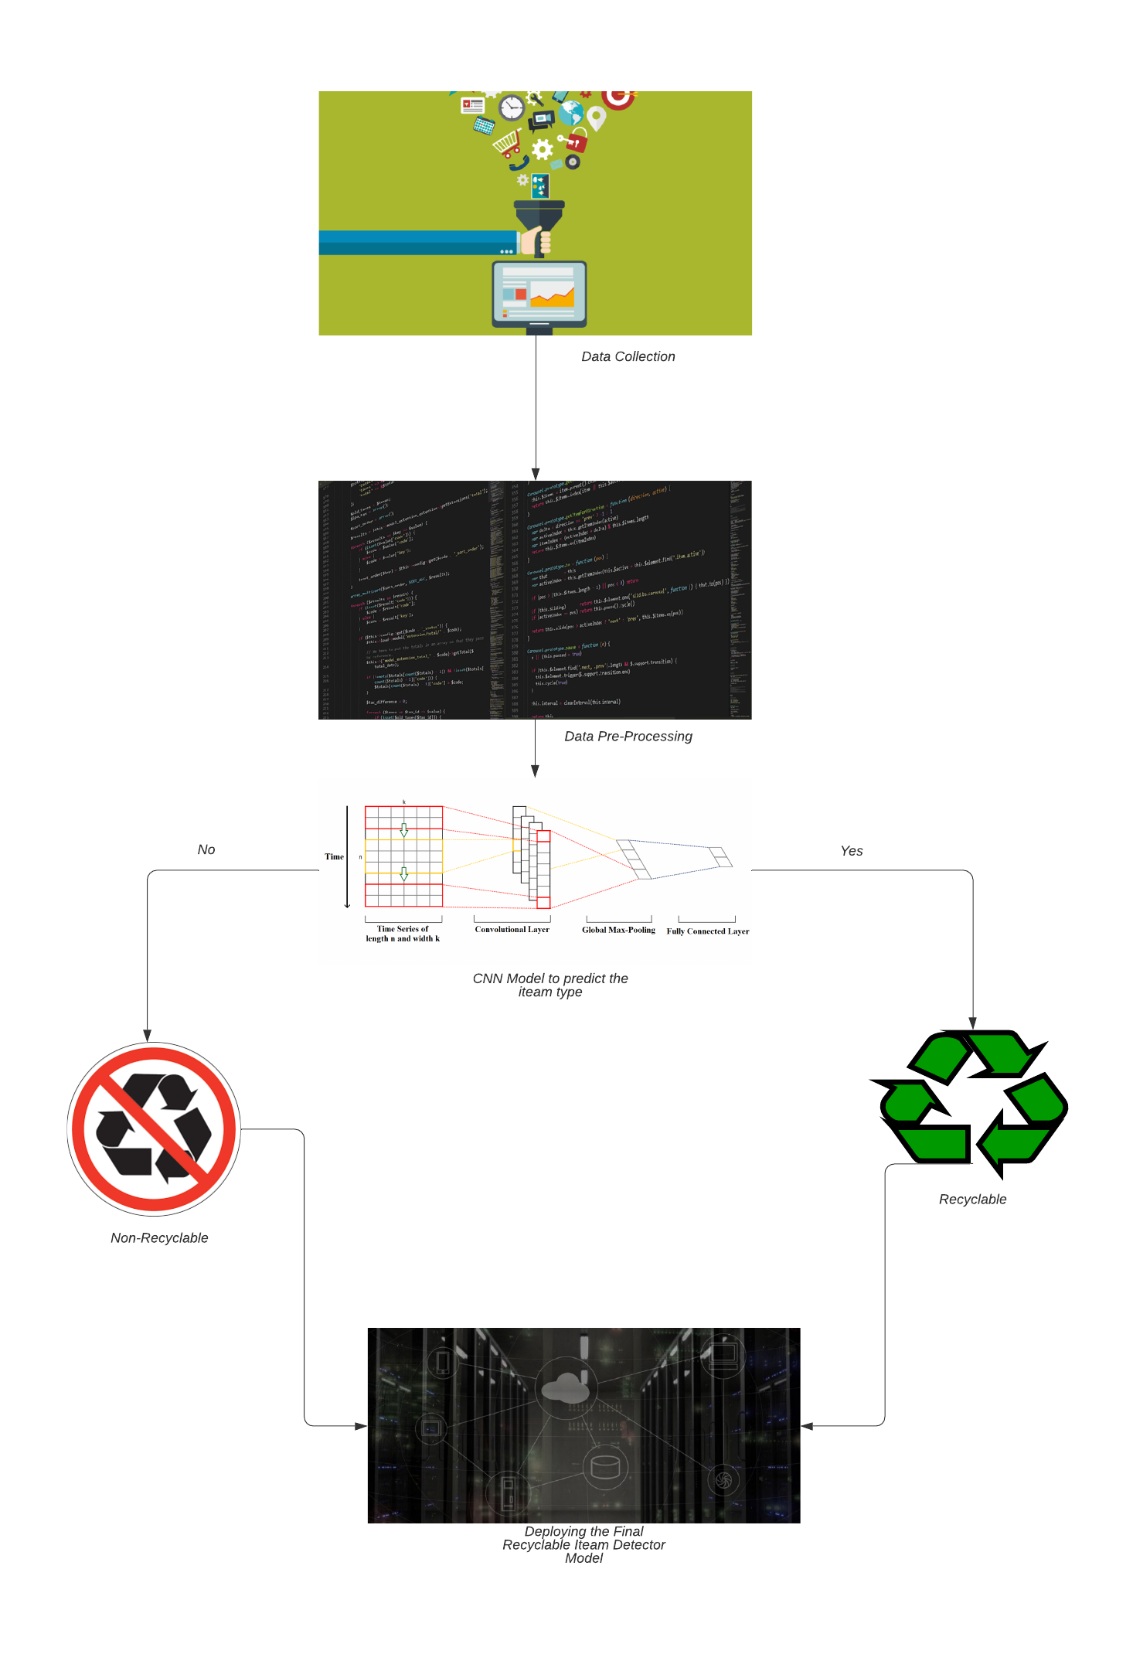

Flow Chart 1

**OBJECTIVES**

The main purpose of this project is to implement the achieved model in day to day life scenario. For instance, embedding this proposed technology in smart-bins which would automatically detect the item as a recyclable or non –recyclable product.

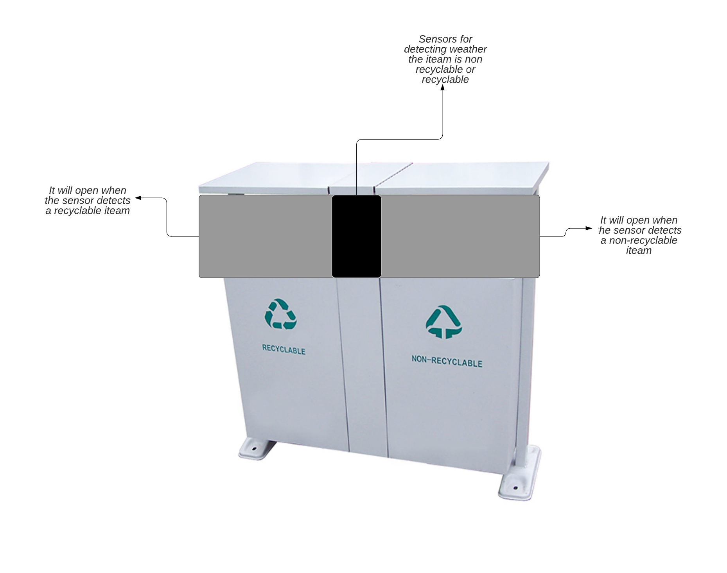

Figure 1:-Future of Smart Bins